IDS Fundamentals - Lab Report

Date: 05/06/2026
Difficulty: Easy
Category: Security Solutions
Platform: TryHackMe

Overview

This lab goes over Intrusion detection systems and how they can be used to secure networks and detect malicious activity on a host or network. It discusses the types of IDS and detection modes as well as a practical exercise of using Snort commands.

2. Toolset Used

Tool | Purpose / Function
Snort | An IDS solution that monitors network traffic in real-time using rules to detect known attack patterns and alerts security teams

3. What I did

Intrusion detection systems (IDS) are used inside a network to check for malicious activities and upon detection, an alert is generated for the security team to analyse. IDS do not act on the alerts, they are used to notify the security team of potential malicious activity. There are 2 deployment modes:

- Host intrusion detection system (HIDS): These are installed on the hosts and are responsible for detecting potential security threats for that particular host. They can be challenging to manage in large networks as they are resource intensive and each host requires management.
- Network intrusion detection system (NIDS): These are responsible for detecting threats within the whole network and any host. They monitor the network traffic of all hosts and provides a centralized view of all detections within a network.

And different detection modes:

- Signature-based IDS: Each attack has its own unique pattern which is known as a signature. The IDS has these signatures in a database so that if the attack happens again, the IDS alert the security team that the signature has been detected again. However, this IDS is unable to detect zero-day attacks as they are new and have no known signature so this type of IDS can only detect previous attacks.
- Anomaly-based IDS: This type of IDS learns the normal behaviour of the network first and then learns detections if there are any changes from normal behaviour. This means that this type of IDS can detect zero-day attacks because they don’t rely on signatures for detection. However, this may generate a lot of false positives which gives the security team a lot more work to do and can cause fatigue. The false positive rate can be reduced by fine-tuning/manually defining the normal behaviour.
- Hybrid IDS: This combines the detection methods of the previous 2 types of IDS to use the strengths of both. It can use signatures to detect attacks and if it finds a new threat then it uses anomaly-based IDS to detect it.

Signature-based IDS can detect threats the quickest as others have a high processing overhead. Signature-based is good for covering a small threat surface. Anomaly-based and Hybrid help detect new, zero-day attacks which are most dangerous for organisations.

Snort is one of the most common IDS solutions as it uses both signature-based and anomaly-based detections to find threats. These are set in the rule files of the Snort tool. There are several built-in rule files for the tool, and it contains known attack patterns. Security teams can configure their own rules to meet their requirements and disable any built-in rules that they do not like or need.

Modes of Snort:

- Packet sniffer mode: Reads and displays network packets without doing any analysis on them. This mode doesn’t directly relate to IDS, but it can be useful for network monitoring and troubleshooting. For example, the network team observe network performance issues, they use this mode to diagnose details of the network traffic.
- Packet logging mode: Snort performs detection in real-time but in some cases the network traffic needs to be logged for later analysis, so this mode logs the traffic as a PCAP file. For example, the security team need to launch a forensic investigation, so they need the logs of previous traffic.
- Network intrusion detection system mode: This is the primary mode that monitors network traffic in real-time and applies rule files to find any matches of known attack patterns. If there is a match, then it generates an alert for the security team to investigate.

You can run Snort normally to only capture your hosts traffic, or you can turn on promiscuous mode of your hosts network interface to detect intrusions across the whole network. You can usually find Snorts built-in rule files and config files in the /etc/snort directory, but this can differ.

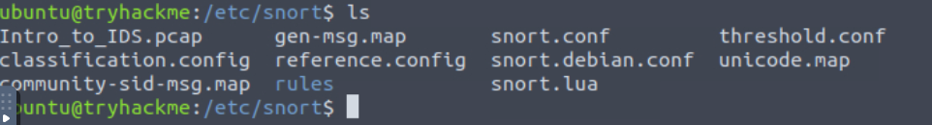

An example of a Snort rule is shown below. This rule would detect ICMP packets coming from any IP and port for the home network to any port. Once this traffic is detected, it generates 2ping detected” alerts.

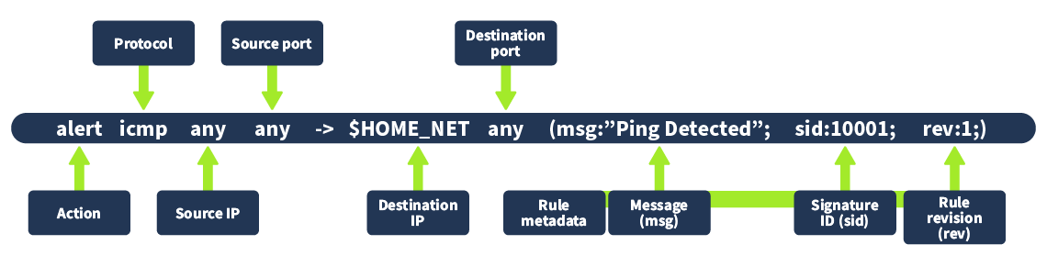

To add this rule, go to /etc/snort/rules/local.rules and copy the rule into the file and save the file

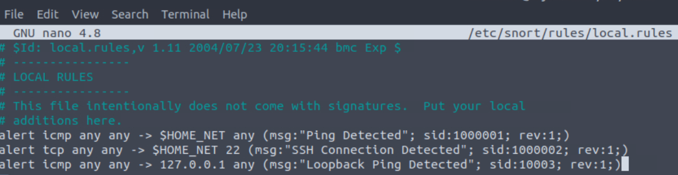

To test this rule, the command below is shown for the loopback interface and when I use a new terminal to ping 127.0.0.1, the alerts come through.

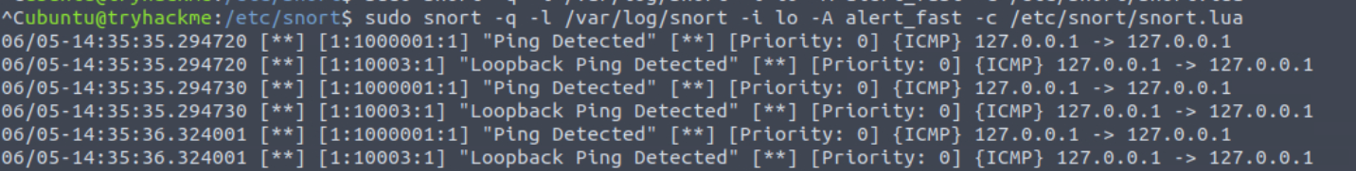

To run PCAP files, use the following command > sudo snort -q -l /var/log/snort -r Task.pcap -A alert_fast -c /etc/snort/snort.lua
Practical

Acting as a third-party forensic investigator, I need to investigate a recent attack on a network. I have been given a PCAP file which contains network traffic from the attack. I start by running the Snort command as shown below which returns lots of logs.

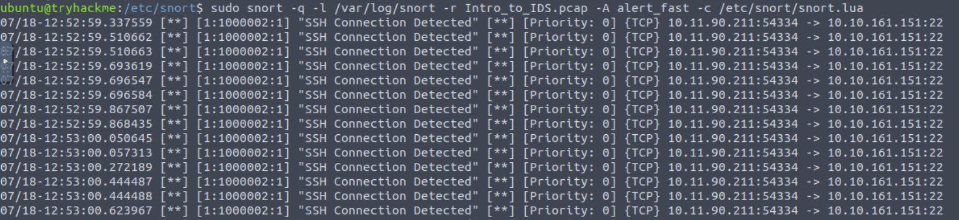

From this we can find that the IP of 10.11.90.211 tried to connect to the machine using SSH. There are also ping detected alerts at the bottom of the logs from this IP address. We can also see that the SID of the SSH connections is 1000002 compared to the Ping detection alerts which are 1000001.

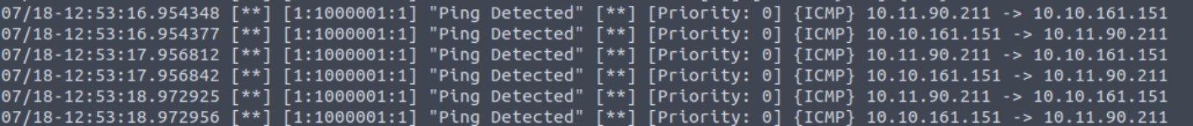

4. What I’ve learned

- How IDS work
- Types of IDS
- Types of IDS modes
- What Snort is
- How to use Snort commands in a practical exercise

